# COMSYS 303 Project 2(Java Project) – Design Report

Rahul Ahluwalia

Vanshika Lal

Department of Electrical and Computer Engineering

University of Auckland, Auckland, New Zealand

[Rahl027@aucklanduni.ac.nz](mailto:Rahl027@aucklanduni.ac.nz)

[Vlal080@aucklanduni.ac.nz](mailto:Vlal080@aucklanduni.ac.nz)

## Introduction

Movies have the power to move us like nothing else, whether they are funny, scary, dramatic, romantic, or somewhere in between. So many titles, so much to discover. However, sometimes it is difficult to obtain some movies and nowadays they’re quite expensive. The purpose of our native Android app is to sell various movies, at a discounted price depending on the year release. All the movies featured in our application will be available to the user to download via the app. The app will initially have 5 different genres, comedy, sci-fi, thriller, action and romance. Each genre will have at least ten unique items. For this Project, Developer 1 is Rahul Ahluwalia and Developer 2 is Vanshika Lal.

The report contains our Design and Planning details. The System Modelling and System Design, which show case diagrams and class diagrams we used to model/design out application. Also shown are GUI mock-ups of how we intend to implement/or want the main activities of our android application to look like regarding colour, layout, and content etc. The project schedule which covers what different aspect each member is covering through a Gantt Chart and the roles of each team member.

## System Modelling

Case Diagram- The Diagram bellow provides the base important cases required for the project, as the key aspect involves showing products to the viewer to purchase. In our case, browse film allows the user to look through the movies/films (product) available through, Top Pick, Genres and Search functionalities. While Purchase Film allows for purchase with its use case shown here, which shows how the user and application would interact, its implementation is not required by the project. While Update Catalogue shows how developers would be able to update the catalogue of films on the application, implementation also not required by the project. Our Case diagram would change and be more detailed, if while doing the project, we decide to pursue a larger feature set, such as a shopping cart, Wishlist for products (Movies), account login etc. So, the case diagram currently only coves the key aspects, we have right now.

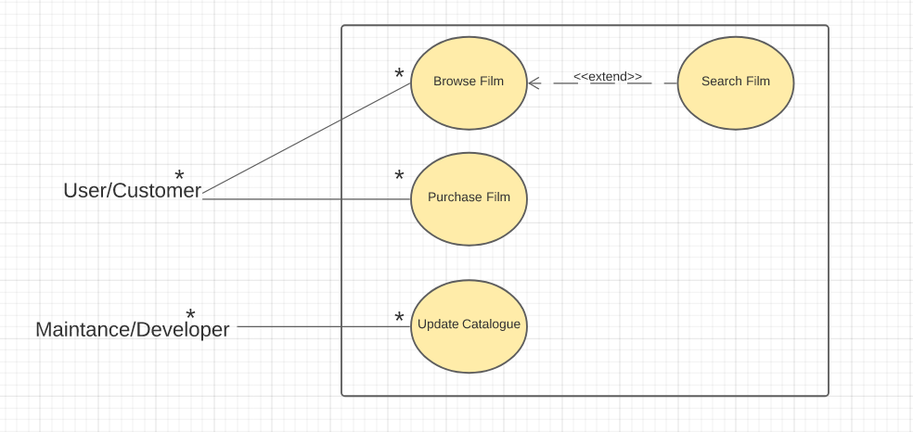

Details on Cases Present:

For Customer/ User, there is the Browse Film Case, where they can look through movies using top picks and different genres. There is also case for browse films using the search feature (Search Film), which is optional, where they can search up films to view/purchase them. Purchase Film is in place for the user to purchase the film they want. Any Customer can browse and purchase as many movies as they want.

The Other Use Case for Maintenance/ Developer is there so the that the developer can update the catalogue, for example adding/removing films. Developers would be able the catalogue as many times as they require.

## System Design

## GUI Design Mocks

The GUI mock-up shows the initial designs of what we intend to do with design/GUI implementations. The Material Design principles were taken into consideration regarding colours, contrast, and layout of the GUI, to ensure its readable. While implementing the GUI for the application through coding, we fully expect to have a somewhat different appearance, but these mock-ups will act as the framework we follow. Since we don’t have any intention to formally publish this application, the usage of images of movie e.g. posters and other images not our own, should be applicable.

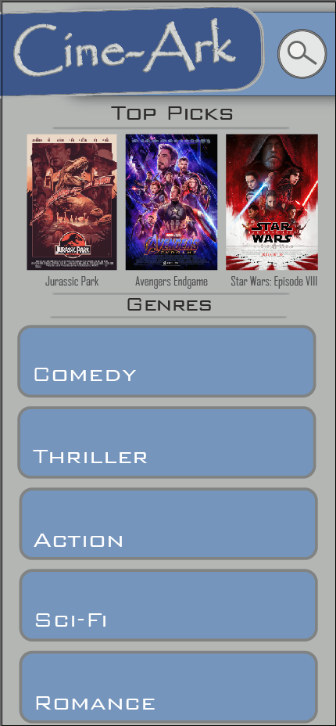 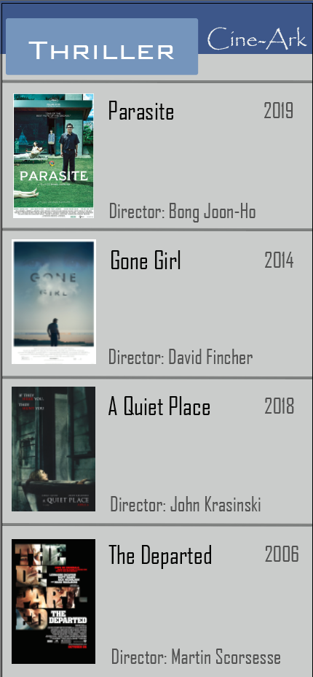 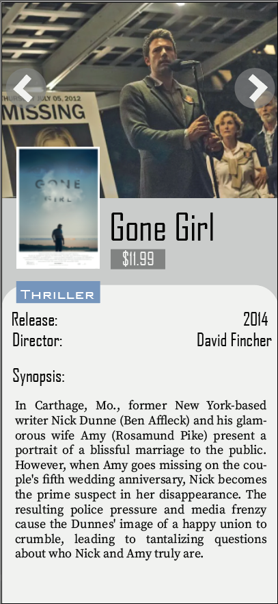 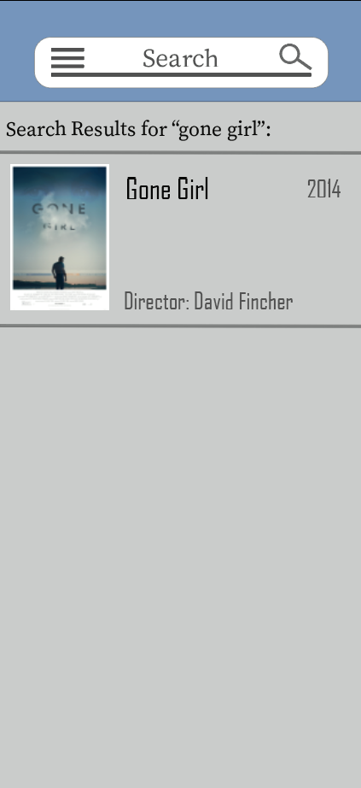

Figure 1: Main Activity Figure 2: Movie-List Activity Figure 3: Movie Detail Activity Figure 4: Search Activity

Main Activity contains top picks, and different categories/genres of movies the user can choose to view and has a search button which leads the user to the Search Activity.

Movie-List Activity displays the user with movies of the category/genre selected on the main activity.

Movie Detail Activity- when user selects a movie, this contains the key information about the movie such as Year-Released, Director, Synopsis and Price. This also contains some images of the film to give the user more information.

Search Activity-The User can search for movie directly, by searching up the movies name, which then provides the user with the search results.

## Project Schedule

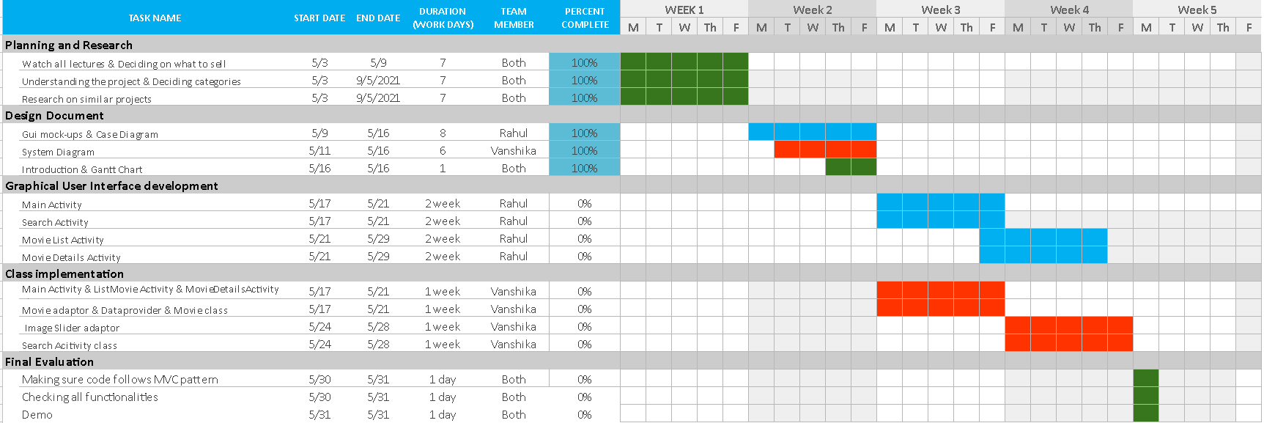

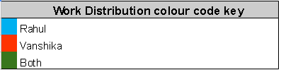

### Role of student

Developer 1 – Rahul Ahluwalia

Working on Application with a focus on GUI design/implementation

Developer 2 – Vanshika Lal

Working on Application with a focus on Class implementations.